**RESTful API Spring Boot Development**

Spring Boot provides a variety of annotations to simplify the development of RESTful APIs. These annotations help you define request mappings, handle input and output, manage cross-origin requests, and more.

Here's a list of commonly used Spring Boot REST controller annotations along with their usage and importance:

1. **@RestController**

Usage: This annotation is used to define a controller that handles HTTP requests. It combines **@Controller** and **@ResponseBody**, meaning the return value of the methods will be serialized into JSON or XML and written directly to the HTTP response.

Importance: **Simplifies the creation of RESTful web services by automatically converting the response to JSON or XML**.

2. **@RequestMapping**

Usage: Used to map HTTP requests to handler methods in the controller. Can be applied at the class level and method level. It allows specifying the URL path, HTTP method, and other request attributes.

Importance: **Provides flexibility in routing requests to specific methods based on URL patterns and HTTP methods**.

3. **@GetMapping, @PostMapping, @PutMapping, @DeleteMapping, @PatchMapping**

Usage: Specialized annotations for mapping HTTP GET, POST, PUT, DELETE, and PATCH requests, respectively. These are shorthand for @RequestMapping(method = RequestMethod.GET) and similar.

Importance: **Simplifies the declaration of request mappings for common HTTP methods**.

4. **@PathVariable**

Usage: Used to extract values from the URI template and bind them to method parameters. For example, /users/{id} can be mapped to a method parameter id.

Importance: **Allows dynamic extraction of values from the URL, enabling more flexible routing and handling of requests.**

5. **@RequestParam**

Usage: Used to extract query parameters from the URL and bind them to method parameters. For example, /search?query=abc can be mapped to a method parameter query.

Importance: **Facilitates the handling of URL query parameters, making it easy to access user inputs from the URL.**

6. **@RequestBody**

Usage: Used to bind the HTTP request body to a Java object. Commonly used for POST and PUT requests where data is sent in the request body as JSON or XML.

Importance: **Enables automatic deserialization of request data into Java objects, simplifying data handling.**

7. **@ResponseBody**

Usage: Used to indicate that the return value of a method should be serialized to JSON or XML and written directly to the HTTP response.

Importance: **Ensures that the response is sent back to the client in the desired format without needing additional configuration.**

8. **@CrossOrigin**

Usage: Used to enable Cross-Origin Resource Sharing (CORS) for specific methods or classes, allowing requests from different origins.

Importance: **Crucial for enabling web applications hosted on different domains to access your API, addressing CORS policy restrictions.**

9. **@ExceptionHandler**

Usage: Used to define methods that handle specific exceptions thrown by request handler methods. Allows custom error handling and response generation.

Importance: **Provides a mechanism to manage errors gracefully and return meaningful error responses to clients.**

10. **@Valid**

Usage: Used to trigger validation on the request data when bound to method parameters. Works with Java Bean Validation (JSR-303).

Importance: **Ensures that incoming data meets validation criteria before processing, enhancing data integrity and security.**

11. **@RequestHeader**

Usage: Used to extract HTTP headers from the request and bind them to method parameters.

Importance: **Allows access to metadata sent with the request, enabling conditional processing based on header values.**

12. **@CookieValue**

Usage: Used to extract cookie values from the request and bind them to method parameters.

Importance: **Facilitates interaction with client-side state stored in cookies, useful for session management and personalization.**

These annotations form the backbone of a Spring Boot REST API, providing the necessary tools to define endpoints, handle requests, manage data, and ensure security and validation. By understanding and utilizing these annotations effectively, you can build robust and efficient RESTful services.

**@Transactional** annotation

The @Transactional annotation in Spring Boot is used to manage database transactions declaratively. When applied to a method or class, it instructs Spring to automatically manage the transaction lifecycle for the operations within that scope

When integrating external APIs into your project, choosing the right approach depends on several factors, including the complexity of the API interactions, the need for advanced features, and the overall architecture of your application. Here are some common approaches and considerations:

**RestTemplate**

**Overview:** RestTemplate is a synchronous client provided by Spring for making HTTP requests. It is straightforward and easy to use for simple API interactions.

**Use Cases:** Ideal for applications that require simple HTTP calls without the need for asynchronous processing or reactive programming.

Pros:

* Easy to set up and use for basic HTTP requests.
* Well-integrated with Spring's ecosystem.
* Supports various HTTP methods and configurations.

Cons:

* Synchronous nature may not be suitable for high-throughput or non-blocking applications.
* Deprecated in favor of WebClient for new applications, especially those using Spring WebFlux.

**WebClient**

**Overview:** WebClient is a non-blocking, reactive client introduced in Spring WebFlux. It is designed for asynchronous and reactive programming, making it suitable for modern applications.

**Use Cases:** Best for applications that require non-blocking I/O, asynchronous processing, or integration with reactive streams.

Pros:

* Supports asynchronous and reactive programming models.
* Suitable for high-throughput applications.
* Provides a more modern API with fluent builder patterns.

Cons:

* May require a shift to reactive programming paradigms, which can be complex for developers unfamiliar with them.

**Feign Client**

**Overview:** Feign is a declarative web service client that simplifies API integration by allowing you to define interfaces for external services.

**Use Cases:** Useful for microservices architectures, especially when combined with Spring Cloud.

Pros:

* Declarative approach simplifies API integration.
* Supports load balancing and circuit breaker patterns when used with Spring Cloud.
* Easy to use with minimal boilerplate code.

Cons:

* May require additional setup and dependencies.
* Less control over low-level HTTP configurations compared to RestTemplate or WebClient.

**Considerations for Choosing the Best Approach**

**Application Architecture:** If your application is built using Spring WebFlux or requires non-blocking I/O, WebClient is the preferred choice. For traditional Spring MVC applications, RestTemplate is still viable, but consider WebClient for future-proofing.

**Complexity and Features**: If you need advanced features like load balancing, retries, or circuit breakers, consider using Feign with Spring Cloud.

**Performance Requirements:** For high-performance applications that require asynchronous processing, WebClient is more suitable.

**Developer Familiarity:** Consider the team's familiarity with reactive programming when choosing between RestTemplate and WebClient.

Ultimately, the best approach depends on your specific requirements and constraints. If you're starting a new project, WebClient is recommended for its modern features and flexibility. For existing projects using Spring MVC, RestTemplate can still be a valid choice, but transitioning to WebClient may offer long-term benefits.

**FeignClient**

Integrating Feign Client into a Spring Boot application involves several steps, including setting up dependencies, configuring Feign, and creating interfaces for external APIs. Below is a detailed guide with code snippets to help you implement Feign Client in a Spring Boot project.

Step 1: Add Dependencies

First, ensure you have the necessary dependencies in your pom.xml for Spring Boot and Feign:

<dependency>

<groupId>org.springframework.boot</groupId>

<artifactId>spring-boot-starter-web</artifactId>

</dependency>

<dependency>

<groupId>org.springframework.cloud</groupId>

<artifactId>spring-cloud-starter-openfeign</artifactId>

</dependency>

<dependency>

<groupId>org.springframework.cloud</groupId>

<artifactId>spring-cloud-starter</artifactId>

</dependency>

Make sure you have the appropriate Spring Cloud version in your pom.xml:

<dependencyManagement>

<dependencies>

<dependency>

<groupId>org.springframework.cloud</groupId>

<artifactId>spring-cloud-dependencies</artifactId>

<version>Hoxton.SR10</version> <!-- Use the latest stable version -->

<type>pom</type>

<scope>import</scope>

</dependency>

</dependencies>

</dependencyManagement>

Step 2: Enable Feign Clients

In your main application class, enable Feign Clients by adding the @EnableFeignClients annotation:

import org.springframework.boot.SpringApplication;

import org.springframework.boot.autoconfigure.SpringBootApplication;

import org.springframework.cloud.openfeign.EnableFeignClients;

@SpringBootApplication

@EnableFeignClients

public class FeignClientApplication {

public static void main(String[] args) {

SpringApplication.run(FeignClientApplication.class, args);

}

}

Step 3: Create Feign Client Interface

Define a Feign Client interface to interact with the external API. Use the @FeignClient annotation to specify the service name or URL.

import org.springframework.cloud.openfeign.FeignClient;

import org.springframework.web.bind.annotation.GetMapping;

import org.springframework.web.bind.annotation.PathVariable;

@FeignClient(name = "user-service", url = "https://api.example.com/users")

public interface UserClient {

@GetMapping("/{id}")

User getUserById(@PathVariable("id") Long id);

}

Step 4: Create a Service to Use the Feign Client

Create a service class that uses the Feign Client to fetch data from the external API.

import org.springframework.beans.factory.annotation.Autowired;

import org.springframework.stereotype.Service;

@Service

public class UserService {

private final UserClient userClient;

@Autowired

public UserService(UserClient userClient) {

this.userClient = userClient;

}

public User getUserById(Long id) {

return userClient.getUserById(id);

}

}

Step 5: Define a Controller to Expose the Service

Create a controller to expose an endpoint that uses the service to fetch data.

import org.springframework.beans.factory.annotation.Autowired;

import org.springframework.http.ResponseEntity;

import org.springframework.web.bind.annotation.GetMapping;

import org.springframework.web.bind.annotation.PathVariable;

import org.springframework.web.bind.annotation.RestController;

@RestController

public class UserController {

private final UserService userService;

@Autowired

public UserController(UserService userService) {

this.userService = userService;

}

@GetMapping("/users/{id}")

public ResponseEntity<User> getUserById(@PathVariable Long id) {

User user = userService.getUserById(id);

return ResponseEntity.ok(user);

}

}

Step 6: Define the User Model

Create a simple model class to represent the user data.

public class User {

private Long id;

private String name;

private String email;

// Getters and Setters

}

Step 7: Configuration (Optional)

You can configure Feign clients further by customizing the configuration, such as setting timeouts or enabling logging.

import feign.Logger;

import org.springframework.context.annotation.Bean;

import org.springframework.context.annotation.Configuration;

@Configuration

public class FeignConfig {

@Bean

Logger.Level feignLoggerLevel() {

return Logger.Level.FULL;

}

}

Step 8: Application Properties

Add any necessary configuration to your application.properties or application.yml file.

feign.client.config.default.loggerLevel=full

Running the Application

Once everything is set up, you can run your Spring Boot application. The Feign Client will handle the HTTP requests to the external API, and you can access the data through your service and controller layers.

This setup provides a clean and declarative way to integrate external APIs using Feign Client in a Spring Boot application. Adjust the configuration and models as needed based on the specific API you are integrating.

API Maintenance

An API gateway can be used to implement both API throttling and API rate limiting to control the rate of incoming API requests, protecting backend services from overload and ensuring fair usage. Throttling limits the maximum number of requests an API can handle within a specific time frame, while rate limiting sets a cap on the number of requests a client can make within a defined period.

API Throttling:

* **Purpose:**

Prevents backend services from being overwhelmed by excessive traffic, ensuring stability and preventing denial-of-service (DoS) attacks.

* **Implementation:**

API gateways use various techniques, like the [token bucket algorithm](https://www.google.com/search?safe=active&rlz=1C1GCEA_enMY1168MY1168&cs=0&sca_esv=ba28415142d5cdfa&q=token+bucket+algorithm&sa=X&ved=2ahUKEwiThcC3ksGOAxWtUGcHHavBDHMQxccNegQIGRAB&mstk=AUtExfDn1412n4rY2USpkJypAyNdBwpEk8hi9jZD7ENDUxwOQ-s_3hcLBPhOoZGIJDKTxjky4kNdtrRtk3-XW8TviwaXkxz8SvonUB_x-Bn2iBPRvxzohFS3QMV32156c4QkDf8&csui=3), to limit the number of requests processed.

* **Example:**

An API gateway might allow a maximum of 100 requests per second, dropping any additional requests beyond that limit.

* **Benefits:**

Protects backend resources, prevents service outages, and ensures a consistent user experience.

API Rate Limiting:

* **Purpose:**

Controls the number of requests a specific client (identified by an API key, IP address, etc.) can make within a defined timeframe.

* **Implementation:**

API gateways track request counts for individual clients and reject requests exceeding the defined limit.

* **Example:**

A client might be limited to 1000 requests per minute, and any subsequent requests within that minute would be rejected.

* **Benefits:**

Prevents individual clients from monopolizing API resources, ensures fair access, and protects against abuse.

API Gateway Features:

* **Usage Plans:**

Many API gateways, like Amazon API Gateway, allow you to define usage plans with specific rate limits and burst limits.

* **API Keys:**

API keys are used to identify clients and enforce rate limits on a per-key basis.

* **Account-Level Throttling:**

Some API gateways also provide account-level throttling, limiting the overall traffic to the API across all users in a specific region.

An API Gateway in Spring Boot microservices acts as a single entry point for all client requests, sitting between the client applications and the individual microservices. It centralizes various cross-cutting concerns and simplifies client interactions with a distributed system.

Key functionalities of an API Gateway in Spring Boot microservices:

* **Request Routing:**

The gateway routes incoming requests to the appropriate backend microservice based on predefined rules (e.g., path, headers). Spring Cloud Gateway is a popular choice for this, utilizing predicates to match requests and route them to specific URIs.

* **Authentication and Authorization:**

It can handle security concerns by authenticating and authorizing requests before forwarding them to the internal microservices, thus protecting the backend services from direct exposure.

* **Rate Limiting:**

The gateway can implement rate limiting to control the number of requests a client can make within a specific timeframe, preventing abuse and ensuring system stability.

* **Load Balancing:**

It distributes incoming traffic across multiple instances of a microservice, ensuring efficient resource utilization and high availability.

* **Request/Response Transformation:**

The gateway can modify requests before sending them to microservices and transform responses before sending them back to clients. This can involve adding/removing headers, modifying payloads, or aggregating data from multiple services.

* **Centralized Logging and Monitoring:**

All requests passing through the gateway can be logged, providing a central point for monitoring API usage, performance, and potential issues.

* **Circuit Breaker:**

It can implement circuit breaker patterns (e.g., with Resilience4j) to prevent cascading failures in a microservices architecture by gracefully handling service outages.

Implementation with Spring Cloud Gateway:

Spring Cloud Gateway, built on Spring Boot and Project Reactor, is a reactive and non-blocking API gateway solution. It allows defining routes, predicates, and filters in configuration files or programmatically to manage traffic flow, security, and other functionalities. For example, a route can be defined with a predicate to match a specific path and a URI to which the request should be forwarded. Filters can then be applied to modify the request or response as it passes through the gateway

JSON payload structure requests & responses for claim-services

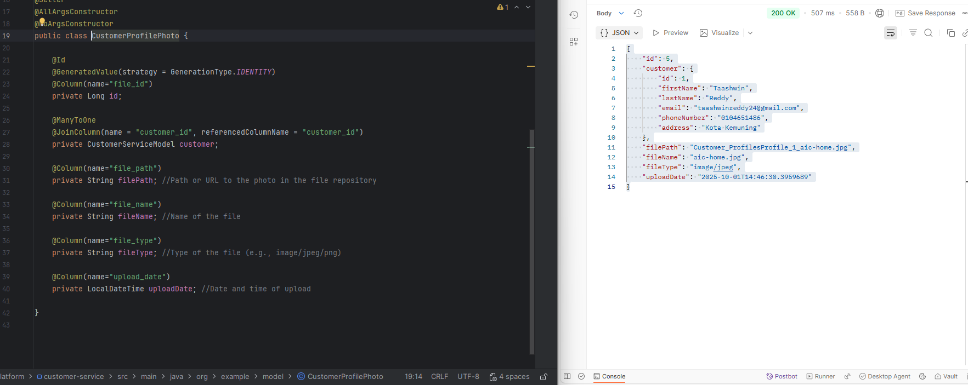

JSON payload structure requests & responses for customer-services

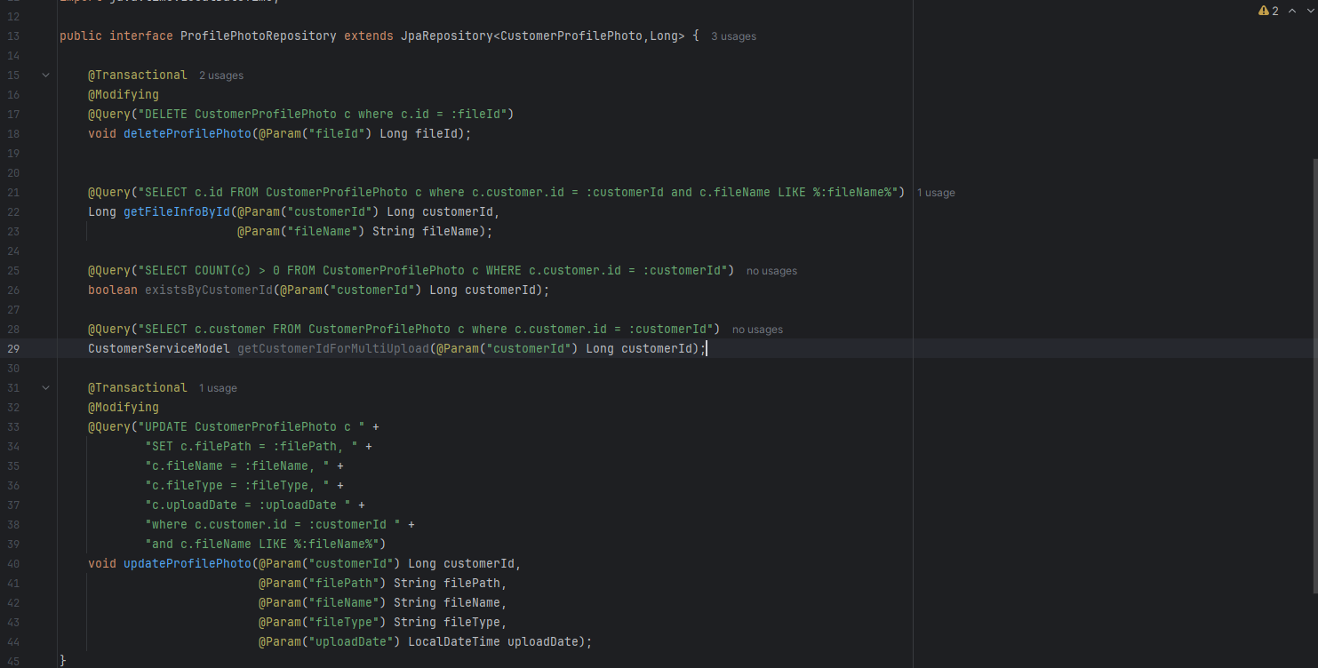

Native Query implementation for customer-service

JSON Payload and Response Structure for Claims-Service – Document Submission

To provide JSON formatted response by implementing Map<String,String> as its ResponseEntity at controller class layer

The mapping of the model class and the JSON response post hitting the API through postman